AI Text Analyzer
A full-stack web application that analyzes text using machine learning to detect sentiment and language. Built with ASP.NET Core 9.0 backend and Vue.js 3 frontend, implementing Clean Architecture and CQRS patterns with ML.NET integration.
MCP servers that I used during creation of project are
- GitHub MCP Server - for creation of branches and pull requests
- Context7 MCP - to find up-to-date architecture for UI and API projects

- first prompt was just to initialize backend project. I wanted to create simple APIs that will be extended by future prompts:
create solution structure which will contain from two parts: frontend and backend.
1. create frontend folder for UI project and leave folder empty for now. we will create UI project later.
2. create backend folder for Web API project
3. create web API project (name TextAnalyzerAPI) use ASP.NET Core and use CQRS pattern. To find best architecture use Context7 MCP.
4. create TextAnalysisController. Add Analyze method which will accept string and store this string in database. And add method to get all saved strings
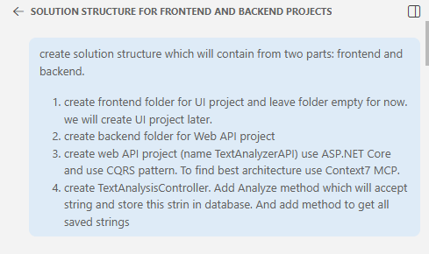

Result from Copilot:
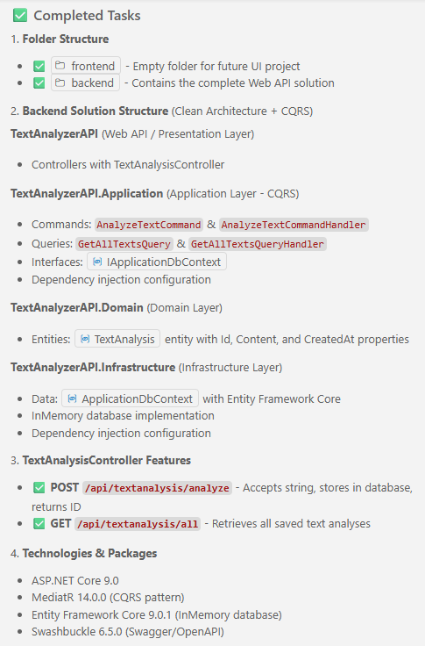

Controller:
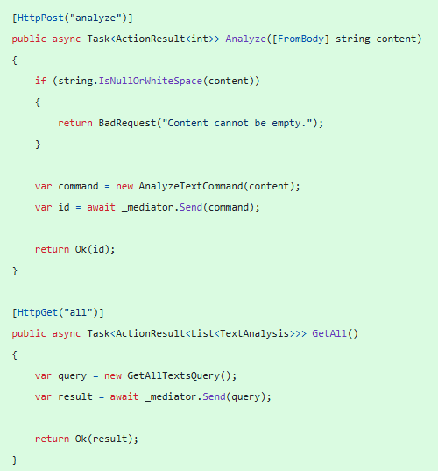
Command handler:
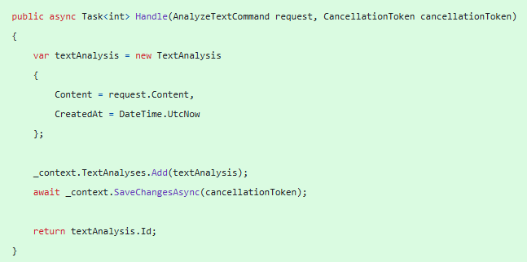

Query handler:
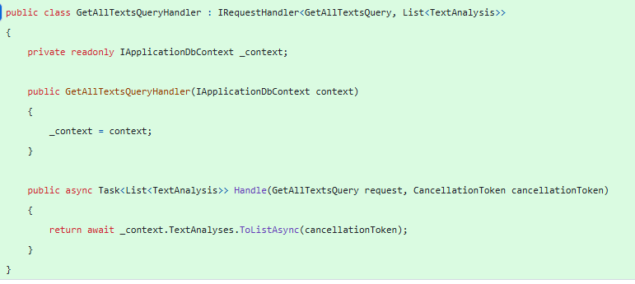

- by next prompt I asked to use SQLite database:

update code to use SQLite database
Result from Copilot:
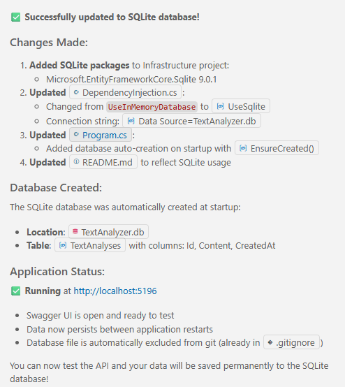
- originally Copilot added DB to API project but I asked to move it to Infrastructure app:
move db with tables to infrastructure project
Result from Copilot:
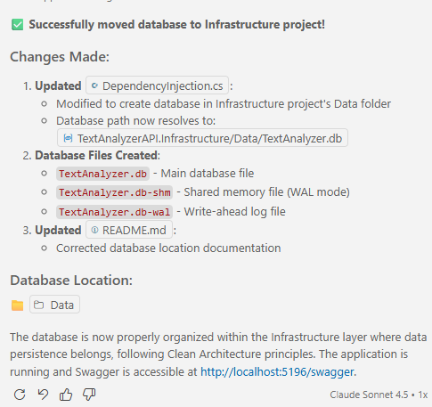

Solution structure result:
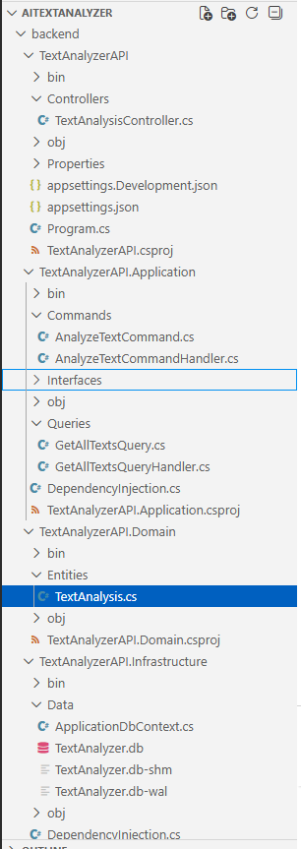

- next prompt was to create service for sentiment text analysis:
1. investigate backend folder to be in context
2. create Service folder inside TextAnalyzerAPI.Application
3. create SentimentAnalysisService. Inside, service creates function which will do sentiment analysis text. Use ML.NET library to do sentiment analysis text.
4. output should be value (Positive / Negative / Neutral) from enum
5. update Analyze handler to use new service to get sentiment analysis
6. update TextAnalysis to store result from sentiment analysis
Result from Copilot:
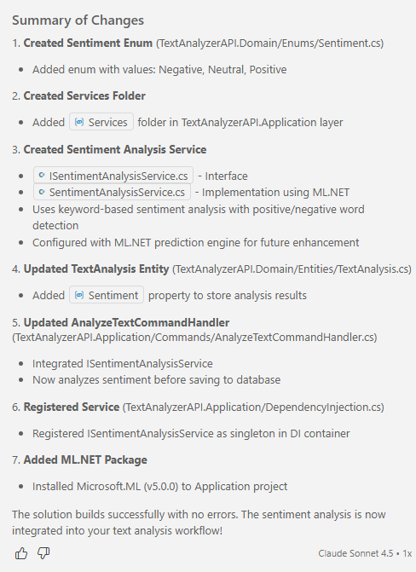
SentimentAnalysisService (it was updated by Copilot during PR review):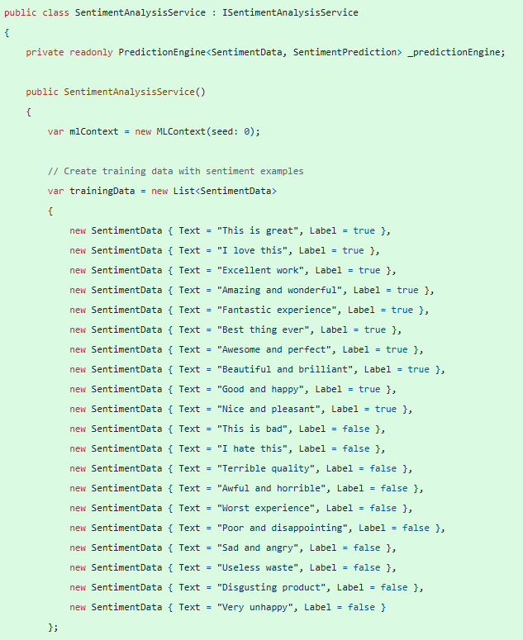
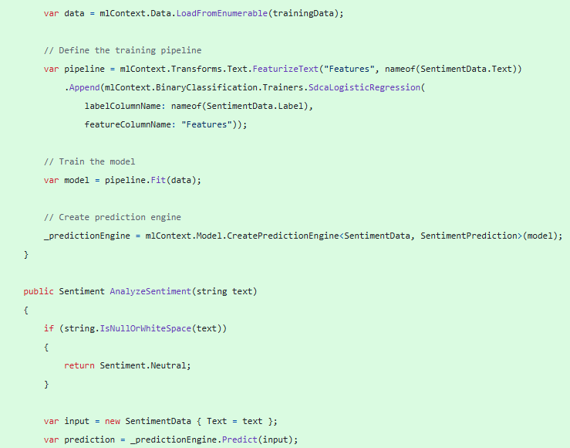
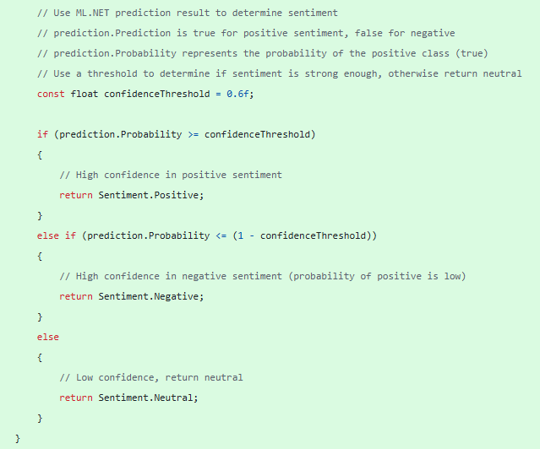
- next prompt was to create one more service to detect text language:
0. create detect-text-language branch and switch to it
1. investigate backend folder to be in context
2. create LanguageDetectionService. Inside, service creates function which will detect text language. Use ML.NET library to detect text language.
3. output should be language name as a string
4. update Analyze handler to use new service to detect text languages
5. update TextAnalysis table to store detected language
6. update AnalyzeTextResponse to return detected language
Result from Copilot:
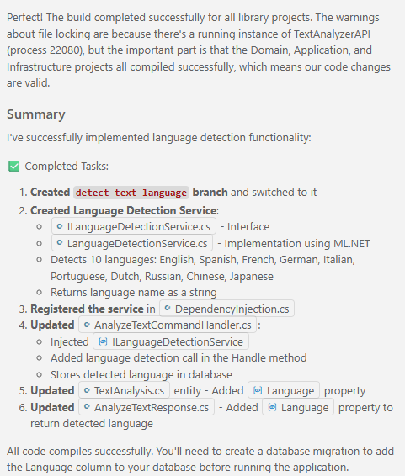

LanguageDetectionService:
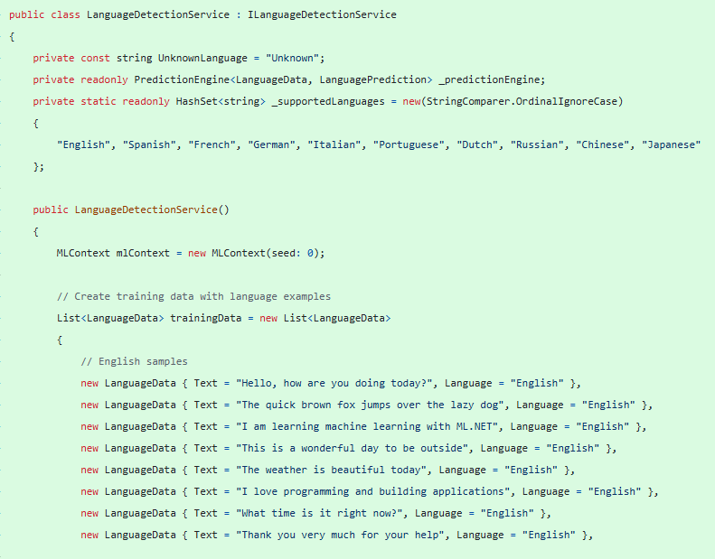
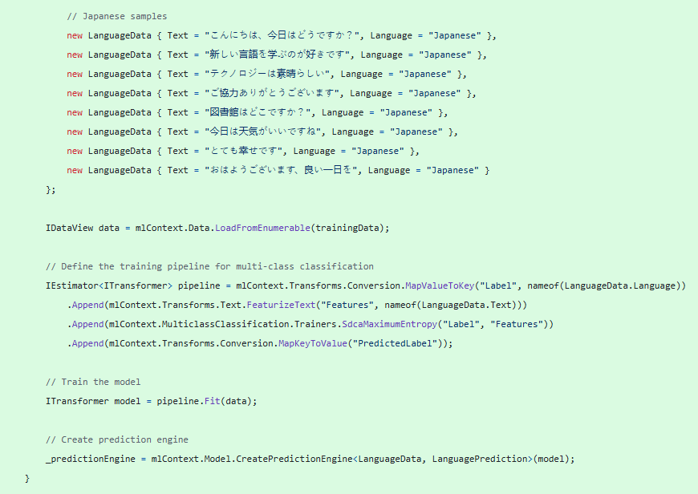
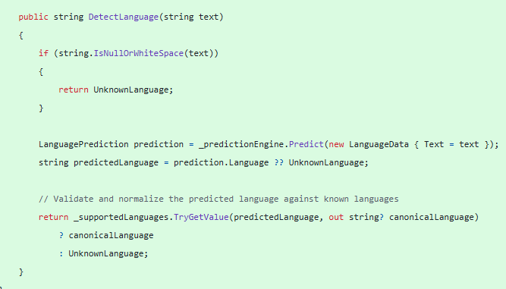

- next prompt was to update SentimentAnalysisService to support same languages as LanguageDetectionService:
update SentimentAnalysisService to support same languages as LanguageDetectionService
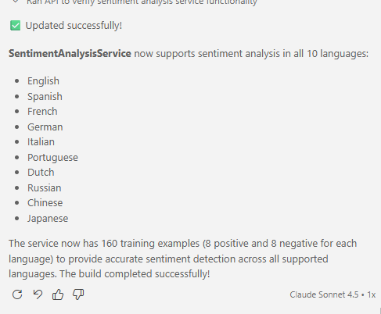

- next prompt was to create UI app based on existing API:
1. investigate backend folder to be in context
2. inside frontend folder create UI app using Vue. Use Context7 MCP to create best architecture.
3. main page should contains textarea to enter text and button Analyze. when User entered text we should pass it to Analyze API and display result: detected language and sentiment.
4. second page - History - to display in table view all previously entered texts and results with date time
5. use bootstrap for styles
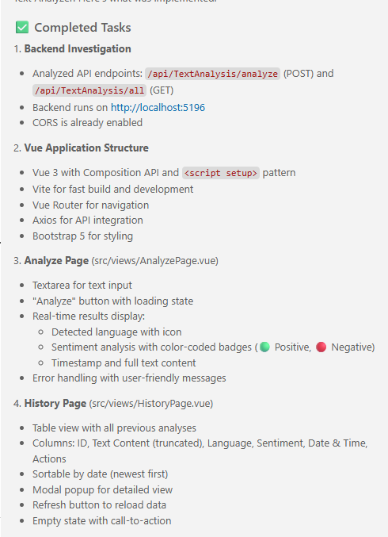

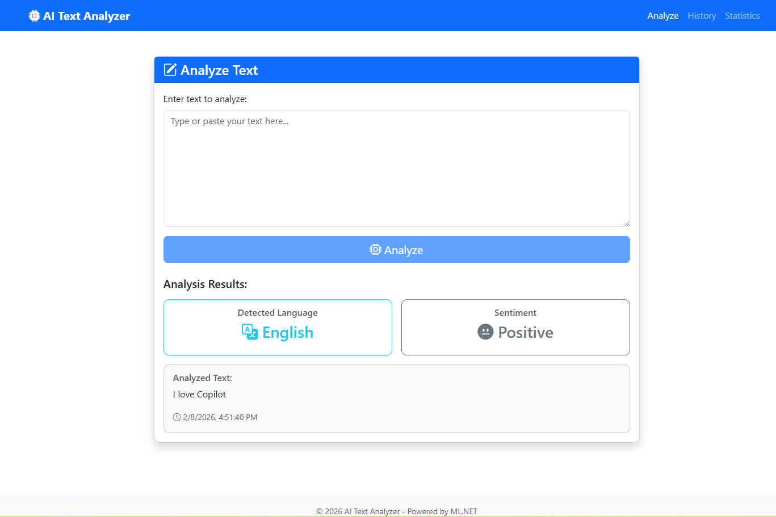

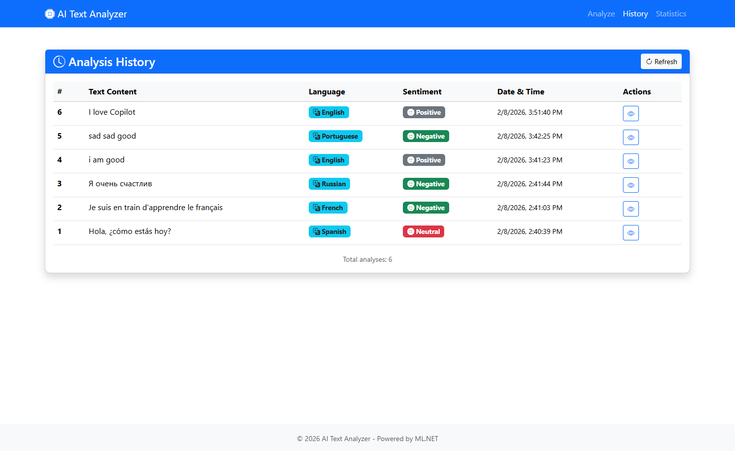

- next prompt was to add Statistics page:
add Statistics page where User will see graphs
- % Positive / Negative / Neutral based on all entered data
- % languages based on all entered data
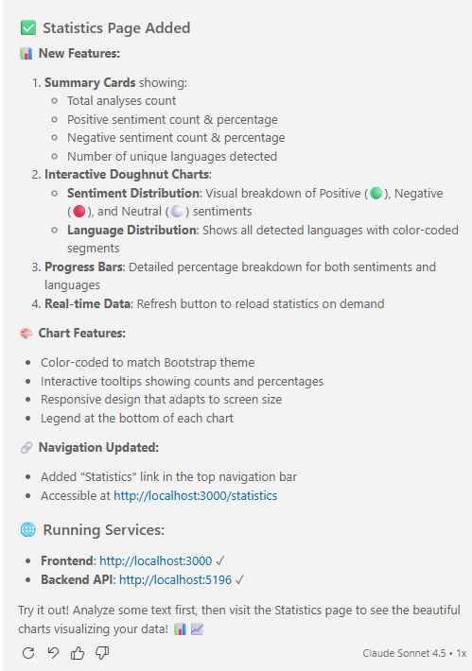

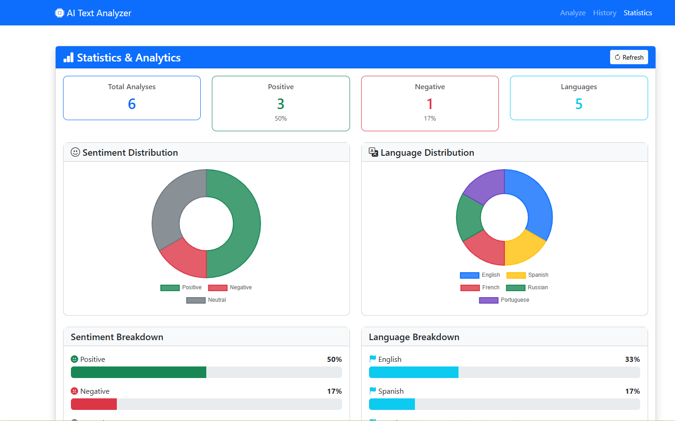

- next prompt was to add admin function but without full authentication (just used hardcoded admin password):
- create admin-layout branch and switch to it
- investigate backend and frontend folders to be in context
- add Login page where User can enter password to get Admin permissions. It will be fake authentication and password can be hardcoded in the code.
- when User entered correct password he will see Delete option for each row on History page. When User will select Delete option the row will be delete from DB.
- add delete API and handler on backend to delete row from DB by ID

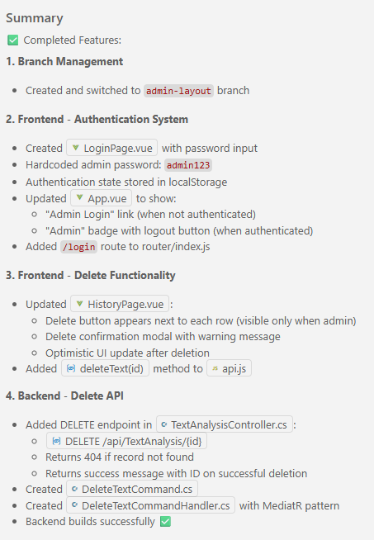
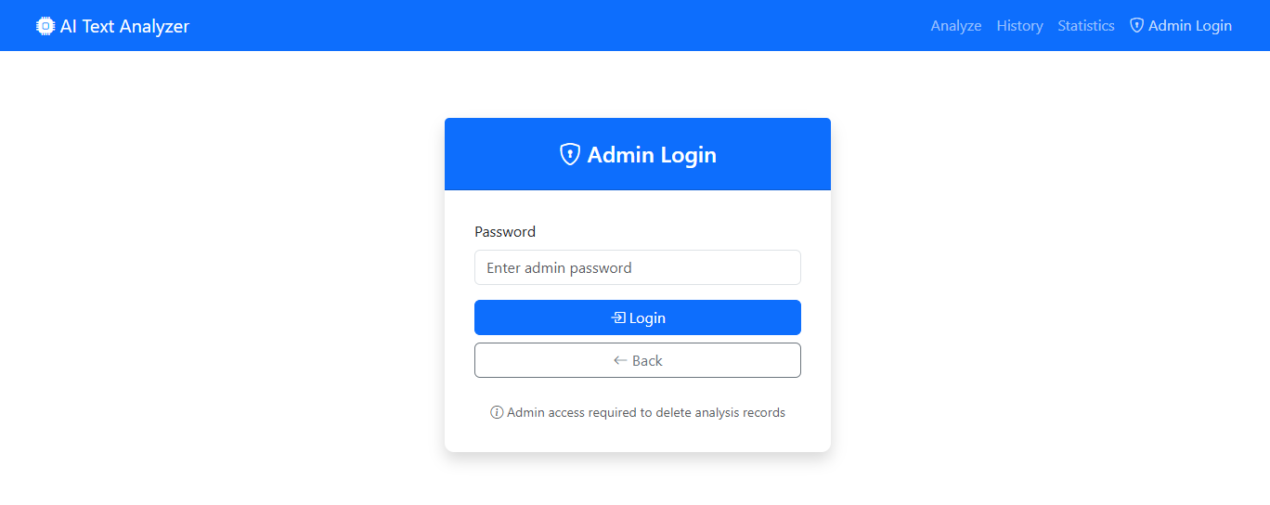

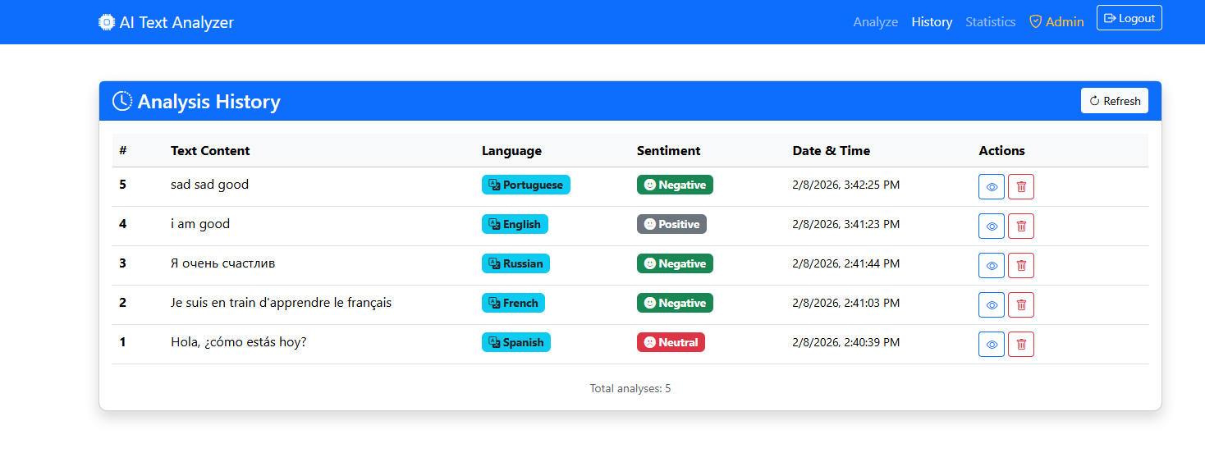

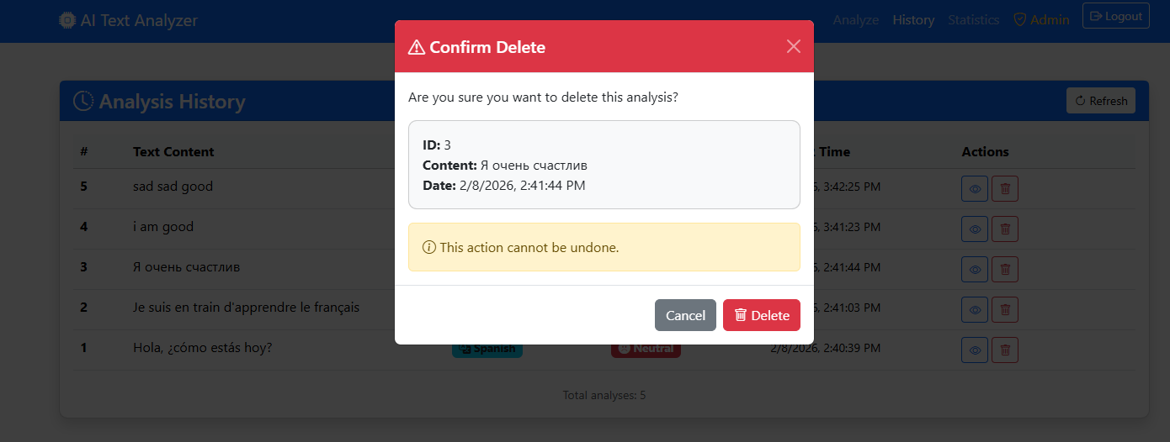

- next prompt was to add unit tests:
add ui and backend unit tests
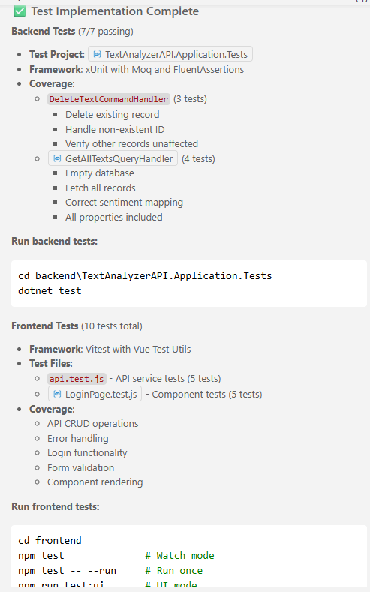
This was my first experience with Copilot, and my first impression was that it's a very powerful tool for app creation. My involvement was minimal. I only wrote prompts, checked the results, and asked for corrections if there were any errors. In my opinion, prompts where I only asked for a specific service or API to be implemented work better than describing a larger task at once.

